**Final Design Requirements**

**Camera Requirements**

**General Requirement**

* The Aircraft Design Team requires a mounted zoom camera that is located near the middle of the vehicle to minimize the reduction in structural/flight performance of the aircraft. The Aircraft Design Team will be designing and manufacturing their own mounts and there is no requirement as to whether they will be fixed mounted or gimbal mounted. It should be able to continuously capture video/image footage of the AOI during the Search phase of motion.

**Subjective Requirements**

* The COE Design Team shall be able to obtain the angle and altitude in which the camera is positioned to obtain aircraft coordinates, attitude, and gimbal angles to determine GPS coordinates of corresponding images.
* The COE Design Team needs to be be able to capture video/image feed of high resolution with flying at the mission altitude (200 ft above sea level)

**Quantitative Requirements**

* The total weight of the imaging equipment needs to be under 4 lbs. If the weight of the imaging equipment exceeds 4 lbs with the airframe currently weighing 12 lbs, then the total weight of the aircraft will exceed the 16 lb. weight limit. This would cause aerodynamic and/or structural issues with the performance of the vehicle.

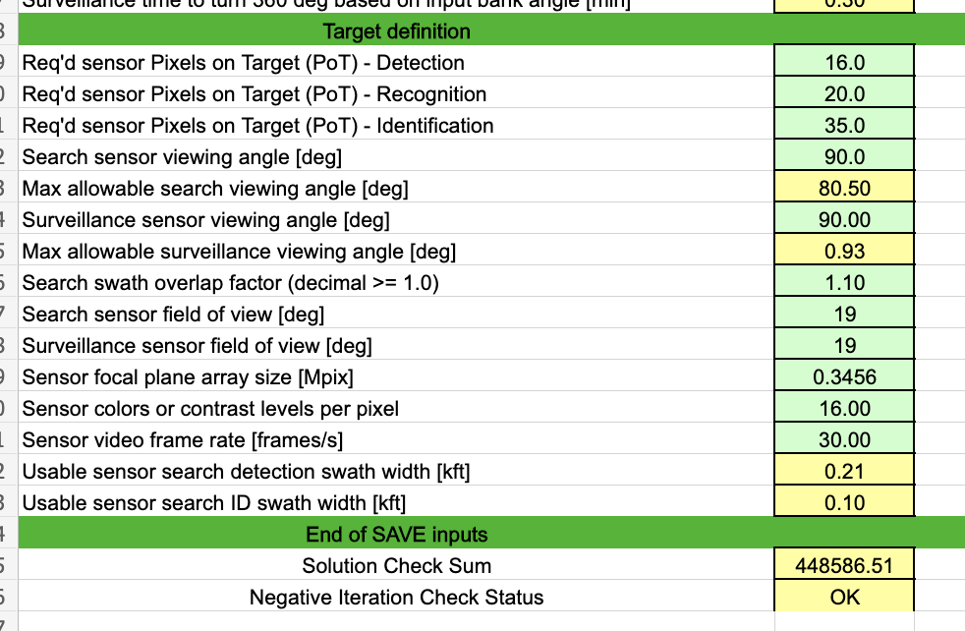

| Required sensor pixels on target (PoT) - Detection | <=12.3 Megapixels | It is expected that the required sensor pixels for detection, recognition, and identification will be the same. Still developing feature mapping algorithm to determine highest resolution that will allow for detection, recognition, and identification above minimum threshold of accuracy (according to confidence intervals and false positive rates) |
| --- | --- | --- |
| Required sensor pixels on target (PoT) - Recognition | <= 12.3 Megapixels | It is expected that the required sensor pixels for detection, recognition, and identification will be the same. Still developing feature mapping algorithm to determine highest resolution that will allow for detection, recognition, and identification above minimum threshold of accuracy (according to confidence intervals and false positive rates) |
| Required sensor pixels on target (PoT) - Identification | < = 12.3 Megapixels | It is expected that the required sensor pixels for detection, recognition, and identification will be the same. Still developing feature mapping algorithm to determine highest resolution that will allow for detection, recognition, and identification above minimum threshold of accuracy (according to confidence intervals and false positive rates) |
| Search sensor viewing angle (deg) |  | Dependent on mounting configuration of camera, will it be positioned directly beneath airframe? Will it be placed on a gimbal? How many DOF will it have? |
| Max allowable search viewing angle (deg) |  | Dependent on mounting configuration of camera, will it be positioned directly beneath airframe? Will it be placed on a gimbal? How many DOF will it have? |
| Surveillance sensor viewing angle (deg) |  | Dependent on mounting configuration of camera, will it be positioned directly beneath airframe? Will it be placed on a gimbal? How many DOF will it have? |
| Search swath overlap factor (decimal >= 1.0) |  | May need to scale the length dimension of image frames to length dimension of associated field in image capture at altitudes between 200 and 230 ft (search altitude) |
| Search sensor field of view (deg) |  | Is this not a fixed property of the camera lens, so, 60 degrees? |
| Surveillance sensor field of view (deg) |  | Is this not a fixed property of the camera lens, so, 60 degrees? |
| Sensor focal plane array size (Mpx) |  | What do we define as the sensor focal plane array? Still 12.3 Mpx? What about 6.287mm x 4.712 mm (7.9mm diagonal) sensor image area? |
| Sensor colors of contrast levels per pixel |  | What do we define as colors of contrast levels per pixel? |
| Sensor video frame rate (frame/s) |  | Believe 60 frame/s but may change depending on accuracy of target identification with feature mapping prototype and/or vibrational effects of UAV on video quality and internal resolution of image partitions |
| Usable sensor search detection swath width (kft) |  |  |
| Usable sensor search ID swath width (kft) |  |  |

**Co-Processor Requirements**

**General Requirement**

* Storage: Co-Processor shall fit the size, weight, and power constraints presented by the ASE Team while being able execute the ATR algorithm within a maximum time interval. Additionally, it should be able to communicate with the camera and the Autopilot.

**Quantitative Input Requirements**

* Power: The co-processor shall run on 5 volts

**Subjective Input Requirements**

* Video: The co-processor needs to be wired to the camera with either a USB or HDMI connection
* Pixhawk Autopilot: The co-processor needs to send and receive information from the Pixhawk quickly (Rate TBR)

**Subjective Output Requirements**

* Identification: The Co-processor needs to have a high enough frequency and enough memory to execute the ATR algorithm in a reasonable amount of time (Time TBR)
* Communication: Co-Processor needs to be able to send the results of the ATR algorithm to the ADP Team

**Automatic Target Recognition Software Requirements**

**General Requirement**

* Storage: Open Source ATR software “fits’ on the co-processor and can operate within the processor’s 4 GB memory capacity.

**Input Requirements**

* Video/Camera: ATR software needs to have the ability to acquire images and video feed from camera through either USB or HDMI connection
* GPS: ATR software needs to have access to GPS module through Pixhawk Autopilot to obtain GPS coordinates of aircraft during the Search phase.

**Output Requirements**

* Identification: The ATR software needs to be trained to identify candidate targets, and distinguish between critical and non-critical targets while the aircraft is in the search phase of motion
* GPS: The software needs to be optimized to obtain raw GPS coordinates from the aircraft and filter according to coordinate transformations, Euler Angles, or other kinematic relationships. The GPS coordinates should be output in a format that is suitable for the ADP Team (i.e. text file or spreadsheet file)
* Map Generation: The software needs to output a digital map containing the identified targets and the associated GPS coordinates in at least a static image.

**Product Engineering Specification Request**

| Target Identification Time | Objective: < 4 min, Threshold: < 12 min |
| --- | --- |
| Power Supply to Co-processor | Objective: <= 5V and <=3 A over USB connection |
| Object Detection | Threshold: 5 targets @ 2m x 2m dimension and search altitude |
| Imaging System Weight | Objective: <= 3.3 lbs, Threshold: <=4 lbs |
| ATR Software Memory Usage | Objective: <= 4GB of RAM |
| Search Accuracy (GPS locations of TOI) | Objective: Error radius <= 20 ft, Threshold: Error radius <= 60 ft |
| Mapping Accuracy | Objective: Error radius <= 15ft, Threshold: Error radius <= 40 ft |